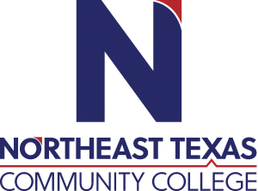 | Karen Pitts, CMA (AAMA), AAS  Office: UHS 102  Phone: 903-434-6383  Email: Kpitts@ntcc.edu
 | “Northeast Texas Community College exists to provide personal, dynamic learning experiences empowering students to succeed.”

Education:

Institution | Major/Areas | Degree | Year(s)
Northeast Texas Community College | Certification in Medical Assisting | AAS | 2011-2013

Teaching Experience:
Institution | Year(s)
Northeast Texas Community College- Adjunct Instructor | January 2016-July 2020
Northeast Texas Community College- Full Time Instructor | August 2020- current

Courses Taught at NTCC (last 3 years):
Medical Terminology, Medical Law and Ethics,
Human Disease and Pathophysiology
Anatomy and Physiology
Clinical Procedures II, Laboratory Procedures, Pharmacology

Significant Professional Publications/Presentations (last 3 years):
N/A

