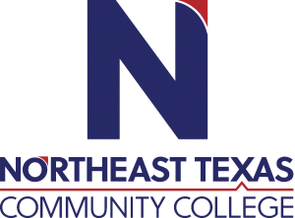 | NAME  Brant E. Davis  Office: Off Campus  Phone: 806-679-1548  Email: bdavis@ntcc.edu
 | “Northeast Texas Community College exists to provide personal, dynamic learning experiences empowering students to succeed.”

Education:

Institution | Major/Areas | Degree | Year(s)
West Texas A & M University | Instructional Design Technology | Masters of Education | 2016
West Texas A&M University | Major in Psychology and a Minor in Sociology | Bachelors of Science | 1990
Amarillo College | Funeral Service Education | Associates of Funeral Education | 2003

Teaching Experience:
Institution | Year(s)
Amarillo College | 9 yrs.
Northeast Texas Community College | 5 yrs.

Courses Taught at NTCC (last 3 years):

Significant Professional Publications/Presentations (last 3 years):
1. MRTS 1301
2. MRTS 2342 2

