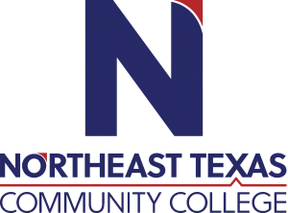 | NAME: Benjamin Schmidt  Office: Funeral Service Education Remote  Phone: (207) 409-5235  Email: bschmidt@ntcc.edu
 | “Northeast Texas Community College exists to provide personal, dynamic learning experiences empowering students to succeed.”

Education:

Institution | Major/Areas | Degree | Year(s)
Thomas Edison State University | Organizational Leadership | MS | 2013-2015
Worsham College of Mortuary Science | Mortuary Science | AAS | 2010-2011
Thomas Edison State University | Natural Science and Mathematics | BA | 2006-2009
Thomas Edison State University | Psychology | BA | 2006-2009
Coastline Community College | Electrical Mechanical Technology | AA | 2005-2006

Teaching Experience:
Institution | Year(s)
Worsham College of Mortuary Science | 2015-2022
Northeast Texas Community College | 2022-Present

Courses Taught at NTCC (last 3 years):
MRTS 1225-Thanatochemistry
MRTS 2231- Human Anatomy
MRTS 2447- Technical Procedures II
MRTS 2342- Mortuary Management II
MRTS 1330- Funeral Service Internship Orientation

Significant Professional Publications/Presentations (last 3 years):
Creating Natural Form: Restorative Art Application and Theory (Revised Edition)
Host The Funeral Science Podcast
Host The Funeralcast
Southern Calls Magazine Winter 2022
Belgian Institute of Thanatopraxie 50th Anniversary (2023)
Co-Host National Funeral Directors Association Funeral Face-Off Trivia (2022- 2024)
Texas Funeral Directors Association Emerging Leaders University (2023, 2024)

