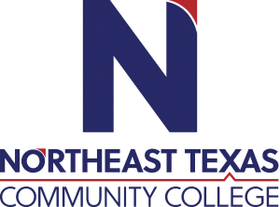 | Jodi Pack  Office: Business Technology 108  Phone: 903-434-8114  Email: jpack@ntcc.edu
 | “Northeast Texas Community College exists to provide responsible, exemplary learning opportunities.

Education:

Institution | Major/Areas | Degree | Year(s)
Gonzaga University | Communications & Leadership | Master of Arts | 2013
Texas A&M-Commerce | Journalism | Bachelor of Science | 2003
Paris Junior College | General Studies | Associate of Science | 2001

Teaching Experience:
Institution | Year(s)
Adjunct Instructor, Texas A&M University-Commerce | 2013-2018
Adjunct Instructor, Texas A&M University-Texarkana | 2016-2021
Adjunct Instructor, Paris Junior College | 2013-Present
Adjunct Instructor/Instructional Coach, NTCC | 2013-Present

Courses Taught at NTCC (last 3 years):
Public Speaking (Speech 1315, Speech 1321)

Significant Professional Publications/Presentations (last 3 years):

