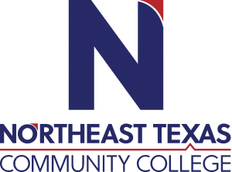 | NAME Donnie Featherston  Office: SS128  Phone: 903.434.8105  Email: dfeatherston@ntcc.edu
 | “Northeast Texas Community College exists to provide personal, dynamic learning experiences empowering students to succeed.”

Education:

Institution | Major/Areas | Degree | Year(s)
University of North Texas | Philosophy | BA | 2000-2004
Southwestern Baptist Theological Seminary | Theology | M.Div | 2004-2007
Brite Divinity School – TCU | Theology and Philosophy | ThM | 2007-2010
University of Denver / Iliff School of Theology | Theology and Philosophy | PhD | 2010-2016

Teaching Experience:
Institution | Year(s)
Front Range Community College | 2011-2015
Butler Community College | 2015-2024
NTCC | 2024-2025

Courses Taught at NTCC (last 3 years): Intro to Philosophy; Ethics

Significant Professional Publications/Presentations (last 3 years):

