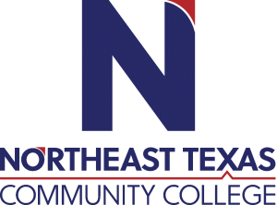 | Kerri Mizell  Office: Harts Bluff Early College High School; Room 851  Phone: 903-577-1146  Email: kmizell@ntcc.edu or mizellk@hbisd.net
 | “Northeast Texas Community College exists to provide personal, dynamic learning experiences empowering students to succeed.”

Education:

Institution | Major/Areas | Degree | Year(s)
Texas A&M - Commerce | Counseling | Masters | 2011
Texas A&M - Texarkana | Curriculum and Instruction | Masters | 2021

Teaching Experience:
Institution | Year(s)
Northeast Texas Community College | Current

Courses Taught at NTCC (last 3 years):
EDU 1300 Learning Frameworks

Significant Professional Publications/Presentations (last 3 years):

