ARTS 1312 - Design II F2F
Course Syllabus: Spring 2021

“Northeast Texas Community College exists to provide personal, dynamic learning experiences empowering students to succeed.”

Instructor: Debbie Strong
Office: H123
Phone: (903) 434-8172
Email: dstrong@ntcc.edu
Office  Hours | Monday | Tuesday | Wednesday | Thursday | Friday | Online
 |  | 930-220 in ceramic lab for class |  |  |  | Email me for anytime

This syllabus serves as the documentation for all course policies and requirements, assignments, and instructor/student responsibilities.

Information relative to the delivery of the content contained in this syllabus is subject to change. Should that happen, the student will be notified.

Course Description: Three credit hours. An introduction to the fundamental terminology, concepts, theory and application of three-dimensional design.

Prerequisite(s): Design I

Student Learning Outcomes:

Identify and apply the elements of art and principles of three-dimensional design. Measured by critical analysis of artwork, sketchbook, and terminology exam.

Employ discipline specific vocabulary in the evaluation of three-dimensional design problems. Measured by critical analysis of artwork, sketchbook, and terminology exam.

Demonstrate creative skill in aesthetic problem solving within assigned parameters. Measured by grading completed art projects and sketchbook.

Demonstrate an appropriate level of professional practice, including safety, craft and presentation. Measured by grading completed art projects, studio maintenance, and participation in art exhibits & final portfolio presentation to the class.

Evaluation/Grading Policy: Explain course exams, grading policy, when grades will be returned to students. (The inclusion of rubrics, if any, should be included as appendices)

Grade percentages:

Assigned projects & critical analyses– 60%

Sketchbook – 15%

Art show participation, studio maintenance/cleanliness & final portfolio presentation – 15%

Written terminology exam & safety exam – 10%

I will give your handwritten feedback/grade in your sketchbook for each project. For your midterm and final grade, you will receive a letter grade that will be posted in the portal. This list shows how letter grades are calculated:
- A - 90 to 100 percent
- B - 80 to 89 percent
- C - 70 to 79 percent
- D - 60 to 69 percent
- F - less than 60 percent

Required Instructional Materials: No textbook is required There is an Essential Guide posted in the Start Course Here folder in Blackboard that you will need to access. You must purchase a clay tool kit and sketchbook from NTCC bookstore before the first class. These two items are bundled together for purchase.

Publisher: NA ISBN Number: NA

Optional Instructional Materials: None

Minimum Technology Requirements: You must have access to a computer and internet to take this course. Your computer needs to have Windows XP SP3 or later or MAC OS X10.3 or higher. You will need high-speed internet access. You can check your operating system by right clicking on the My Computer icon on the home screen. Computers and internet access are available in the NTCC computer lab located in the Learning Commons, but this may be limited availability during spring 2021 due to COVID-19.

Required Computer Literacy Skills: Blackboard Learning Management System, email skills, Remind app

Course Structure and Overview: Brief explanation of major course requirements.

Six projects:

1. Pinch pot - 3 rattles

2. Coil - vase or your choice of a coil project - must be at least 12 inches in height AFTER firing.

3. Soft slab construction - three masks with a unified theme

4. Leather hard construction - box and 1 carved tile

5. Slump or hump mold – bowl

6. Sculpting - figure with mixed media- must be at least 12 inches in height AFTER firing.

All projects must be roughly sketched out in your notebook before starting to work. Document your work and lessons learned in your notebook. Write down your glazes used. Write down what technique you used. Annotate the design terminology used in each project.

Other Course Requirements:

1.Two 25-pound bags of clay are provided by the NTCC Art Department as well as some glazes and other supplies. You may have to purchase some of your clay if you use more than is provided.

2. Some tools are provided, but you must buy a basic pottery tool kit. You can find the supplies at the college bookstore.

3. You must bring other optional supplies as needed such as an apron or shirt, towel, etc. Many texture tools can be found at home or the Dollar Store, such as wooden spoons and texturing objects. Be creative! 4. You will have a storage cubby to store your tools; make sure you mark your tools with your name with a permanent marker.

5. You will need a notebook/sketchbook for sketches, notes, and ideas. Record all your glaze techniques, so that you can share and replicate the technique again. Label your drawings/projects/ideas with design terminology.

6. Outside reading and online research are required.

Communications:
Remind tool- You are required in this course to sign up for the text message notifications. Please follow the instructions in the Start Course Here folder. This is a tool called Remind that I use to get information out to students quickly. This will enable you to receive important class announcements and reminders from me via text message, so that you will not miss any assignment changes or important updates. You can reply to these messages or send me texts through Remind at any time.
Please continue to check your NTCC email daily. If you do not own a cell phone, you can receive these same Remind texts through your email.
Please understand that I will NOT have access to your cell phone number when using the Remind app.

Email communications must be from NTCC email; this is the official communication at NTCC. You must access your email daily through the Eagle portal. Download the Outlook app on your cell phone and set up an account with your school email. Announcements will be sent from the instructor via Blackboard.

Emails to me will be answered within 24 hours. Email is the best way to get hold of me. My email is dstrong@ntcc.edu. When emailing me, please include your student ID number, first and last name as you are enrolled in the course, and what course you are in (this course is ARTS1312 Design II).

Institutional/Course Policy:
1. More than two absences may be detrimental to your final grade, and more than four absences will result in you being dropped from the course or a failing grade.

2. You must be punctual and attend class regularly.

3. Wear comfortable clothing and shoes that are appropriate to working with equipment and supplies in the ceramic lab. Floors may be wet and slippery.

4. Make up work is your responsibility.

5. Use class time wisely to complete your assigned projects.

6. Come to class with plenty of enthusiasm and energy for creating your very best artwork.

7. Effort, progress, and improvement during the semester will be noted.

8. If you use a tool, clean it, and return it to the correct storage area. If you make a mess, clean it up. Wipe down your work area before leaving class. Keep it CLEAN! Studio maintenance is your responsibility.

9. Students must respect other student's work as if it were their own and not touch any work except their own without permission.

10. Unfired clay is to be recycled, not thrown away.

11. Apr 8 is the final day to withdraw with a “W” grade.

12. Turn volume off on cell phones when in the classroom. Step outside if you must talk on the phone, or talk quietly if it is a very short conversation. You can use ONE ear bud to quietly listen to music.

13. No open-toed shoes.

14. You must check NTCC email and Blackboard weekly, but preferably daily.

15. There are no firm due dates listed in the calendar for this course, but I will tell you when something should be done. All work must be completely glazed and fired by May 12, 2021.

NTCC Academic Honesty/Ethics Statement:
NTCC upholds the highest standards of academic integrity. The college expects all students to engage in their academic pursuits in an honest manner that is beyond reproach using their intellect and resources designated as allowable by the course instructor. Students are responsible for addressing questions about allowable resources with the course instructor. Academic dishonesty such as cheating, plagiarism, and collusion is unacceptable and may result in disciplinary action. This course will follow the NTCC Academic Honesty and Academic Ethics policies stated in the Student Handbook. Refer to the student handbook for more information on these subjects.

ADA Statement:
It is the policy of NTCC to provide reasonable accommodations for qualified individuals who are students with disabilities. This College will adhere to all applicable federal, state, and local laws, regulations, and guidelines with respect to providing reasonable accommodations as required to afford equal educational opportunity. It is the student’s responsibility to request accommodations. An appointment can be made with the Academic Advisor/Coordinator of Special Populations located in Student Services and can be reached at 903-434-8264. For more information and to obtain a copy of the Request for Accommodations, please refer to the special populations page on the NTCC website.

Family Educational Rights and Privacy Act (FERPA):
The Family Educational Rights and Privacy Act (FERPA) is a federal law that protects the privacy of student education records. The law applies to all schools that receive funds under an applicable program of the U.S. Department of Education. FERPA gives parents certain rights with respect to their children’s educational records. These rights transfer to the student when he or she attends a school beyond the high school level. Students to whom the rights have transferred are considered “eligible students.” In essence, a parent has no legal right to obtain information concerning the child’s college records without the written consent of the student. In compliance with FERPA, information classified as “directory information” may be released to the general public without the written consent of the student unless the student makes a request in writing. Directory information is defined as: the student’s name, permanent address and/or local address, telephone listing, dates of attendance, most recent previous education institution attended, other information including major, field of study, degrees, awards received, and participation in officially recognized activities/sports.

Tentative Course Timeline (*note* instructor reserves the right to make adjustments to this timeline at any point in the term):

Design II Spring 2021 Calendar
930am-2pm on Wednesdays in IA107 the ceramic lab. Spring semester runs 1/19/2021 – 5/13/2021.
The calendar is a guide, and the instructor may change dates and/or assignments.

Jan 20 – first class day. introductions; discussion of assignments, syllabus, rubric for ceramics; lab; safety; tools, school email, Remind app, and Blackboard; basic clay terminology list; design elements and principles on Blackboard; discuss student art show & final portfolio. Start pinch pots – 3 rattles. HOMEWORK: Sketch out ideas in your notebook for coil project. Look at this website for inspiration: http://www.lakesidepottery.com/Pages/Pictures/Handbuildingprojects-ideas-pictures.html

Jan 27–. Discuss elements and principles of design. Design terminology list and definitions are on Blackboard. Begin coil project –must be at least 12 inches (after firing) in height. Sketch out ideas in your notebook for masks. You must have a unifying theme for your masks. HOMEWORK: Study design elements and principles. Watch Epi Cai’s youtube video on mask making at: https://www.youtube.com/watch?v=iOe5-EDpQE0

Feb 3 – Soft slab construction of three masks with a theme. HOMEWORK:Sketch out ideas in your sketchbook for a box with lid and two tiles. What design elements and principles will you emphasize? Watch video online (about 40 minutes long) of leather hard construction box BEFORE next class. The ceramicist is Melody Cooper, and her video is on youtube at https://www.youtube.com/watch?v=oAj81dhBl0E

Feb 10 –Complete coil project and mask project for bisque firing. Critique of work completed so far.

Feb 17 – leather hard construction – box and 1 tile. Think about design elements and principles as you create. Write them in your sketchbook. Critique of work completed so far.

Feb 24– glazing and firing techniques. Sketch out ideas in your notebook for hump/slump mold bowl. Annotate design elements and principles in your sketchbook. Critique of work completed so far.

Mar 3 – slump/hump mold – bowl or project approved by me. Sketch out ideas in your notebook for figure with mixed media. Label your different techniques and design elements/principles. Critique of work completed so far.

Mar 10 – Sculpt a figure (human or animal) with mixed media, imaginary or real, at least 12 inches in height. Critique of work completed so far. HOMEWORK: Study terminology.

Mar 17 – NO CLASS –Spring break is March 15-19. (midway through term)

Mar 24 – Critique of work completed so far. Keep your sketchbook up to date.

Mar 31 –terminology exam available on Blackboard. Continue work on projects. Keep your sketchbook current with ideas, techniques, and glazes used. Critique of work done so far.

Apr 7 – Continue work on projects. (Apr 8 is the final day to withdraw with a “W” grade.) Critique of work done so far. Set up student art show at Whatley. All must enter items, and all must participate in set ups.

Apr 14 – continue working on projects. Critique of work done so far.

Apr 21 –sketchbook review. All completed work MUST BE brought for review and critique. Pieces must be dry and ready for bisque or glaze firing. If you are working on an AA in art/graphic design, please see me for advising for your fall 2018 schedule. Student art show reception is at 1230 in the Whatley Center foyer. Refreshments will be served. Ribbons will be awarded. Bring a friend; bring a family member. Social distancing and masks are required.

Apr 28 - All work should be very close to completion. All glazing must be completed. Please see me for advising for your fall 2021 schedule.

May 5 –Sketchbook will be graded. Take down student art show.

May 12 - LAST CLASS. All work MUST BE completely done and physically present and shown to me and to the class. Thorough clean-up of clay lab. Remove all personal items from cubby hole. No final exam.

Art exhibits in the Whatley this spring 2021:
Mount Pleasant Art Society Show should run from Sat, Mar 6 (they have their reception that day) through Thurs, Mar 25. The Whatley will be closed during spring break (Mar 15-19).
NTCC Student Art Show should run Thurs, Apr 8 through Tues, May 4. The reception should be Wed, Apr 21 at 1230.
Spring 2021 Calendar for NTCC
Spring Semester
Payment due for Spring classes | 01/08/2021
Martin Luther King Jr holiday | 01/18/2021
First day of Spring classes | 01/19/2021
Late registration ends | 01/22/2021
May graduation application opens | 01/01/2021
Last day to charge in bookstore for Spring | 02/02/2021
Last day to withdraw from a 1st 5-week course | 02/11/2021
Deadline for Spring loan applications | 03/01/2021
Last day to withdraw from a 1st 8-week course | 03/02/2021
Spring Break | 03/15/2021 - 03/19/2021
May graduation application deadline | 03/05/2021
Last day to withdraw from a 2nd 5-week course | 03/25/2021
Priority deadline for Summer financial aid | 04/01/2021
Last day to withdraw from a full semester course | 04/08/2021
Last day to withdraw from a 3rd 5-week course | 04/29/2021
Last day to withdraw from a 2nd 8-week course | 04/29/2021
Final Exams | 05/07/2021 - 05/13/2021

Appendices for Rubrics
The Essential Guide for Design II has the rubric (on page 21) that I will use to grade your projects, but here are examples are what you should look for in your projects. Parts of these rubrics will be used in your sketchbook as indicated in the classroom lectures; use what is in these rubrics to add to your sketchbook entries.
https://www.bulbapp.com/u/ceramics-self-assessment-rubric
https://sites.google.com/a/east-haven.k12.ct.us/stevensart/ceramics-1

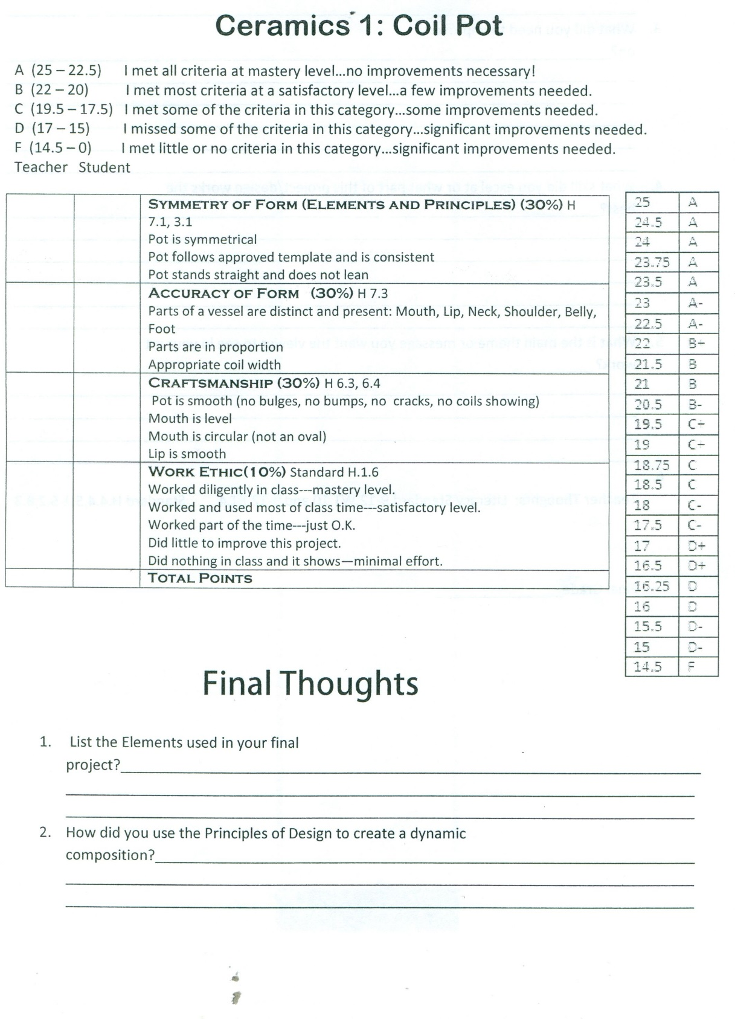

Add together and give yourself a score below. | EXCEEDS  EXPECTATIONS  10 points | MEETS  EXPECTATIONS  9 points | PROGRESSING TOWARDS EXPECTATIONS  8 points | BEGINNING  7-0 points | RATE  YOURSELF | TEACHER’S  SCORE
USE OF SLABS | Slab is an even thickness (¼ inch thick). | Most of the slab is the same thickness with minor imperfections. | Slab is uneven. Needs work. | Very lumpy and uneven. Needs a lot of work.
SURFACE  TEXTURE | No visible cracks. Surface is free of lumps, beads of extra clay. | Few cracks. Few unwanted lumps and beads of extra clay. | Multiple cracks and significant unwanted lumps and beads of extra clay. | Too many cracks, beads of extra clay and lumps.
CONCEPT | Student has created a unique, original, sophisticated project that clearly expresses their theme. | Student has created a project that clearly expresses their theme. | Student has created a project that does not clearly express their theme. | The theme is not clear does not communicate the idea/is sloppy, incomplete.
GLAZING | The glaze was applied evenly and significantly enhances surface quality. | The glaze was applied evenly and enhances surface quality. | The glaze was applied unevenly and does not enhance surface quality. | The glaze was applied unevenly and detracts from surface quality.
EFFORT | Class time was used very wisely. Significant time and effort went into the project. It is clear the student worked to the best of their ability. | Class time was used wisely. Time and effort went into the project. | Class time was not always used wisely and student could have put in more effort. | Class time was not used wisely and the student put in very little effort/incomplete due to lack of motivation.
TOTAL POSSIBLE  POINTS: 50 |  |  |  |  | Your total: | Teacher total:

PROJECT PLANNING SHEET

List 5 possible themes for your project:
1
2
3
4
5

What theme did you choose for the project?

Draw a picture of how you imagine the project will look when completed:

How tall will the project be?

How long will the slab have to be to make the project?

