ARTS 2356.021 – Photography I - Hybrid

Course Syllabus: Spring 2021

“Northeast Texas Community College exists to provide personal, dynamic learning experiences empowering students to succeed.”

Instructor: Daniel Sanchez
Office: HUM 108
Phone: 903-434-8255 (HUM Secretary, Delbra Anthony)
Email: dsanchez@ntcc.edu (Best way to contact me)

Office  Hours | Monday | Tuesday | Wednesday | Thursday | Friday | Online
 | Class 8-9:20  9:30-12 |  | 9:30-12 |  |  | M-F  By Appointment

This syllabus serves as the documentation for all course policies and requirements, assignments, and instructor/student responsibilities.

Information relative to the delivery of the content contained in this syllabus is subject to change. Should that happen, the student will be notified.

Course Description: 3 Credit Hours
A studio art course that introduces the technical and conceptual basics of photography as a creative medium. Manual digital camera required.

Prerequisite(s): None.

Student Learning Outcomes:
Upon successful completion of this course, students will:
- Demonstrate knowledge of manual camera operation, including shutter speed, aperture, and ISO. (hands-on evaluation)
- Demonstrate the techniques of wet and/or dry photographic processes. (photo assignment)
- Apply the elements of art and principles of design to photographic works. (photo assignment)
- Analyze and critique printed photographic works verbally and/or in writing. (oral or written critiques)
- Employ discipline-specific vocabulary in the evaluation of traditional and contemporary photography. (oral or written critiques)
- Relate photographs to historical and contemporary developments in the field. (oral/and or in writing presentation supported with Power Point slides)
- Demonstrate an appropriate level of professional practice, including safety, craft, and presentation. (prepare for and participate in student art show)

Evaluation/Grading Policy:
Photoshoot Assignments = 20%
Studio/Gallery Assignments =20%
Photo Essay = 25%
Quizzes = 15%
Creative Projects = 5%
Discussions = 5%
Terminology Exam = 5%
Critique = 5%

Final Grade = 100%

A (90%-100%) B (80%-89%) C (70%-79%) D (60%-69%) F (59% & Below)

Grades will be returned to the student as follows:
All grades will be posted to the student gradebook on Blackboard within one week of the due date. Please review the tentative course outline for course due dates. A due date schedule is also posted in the Start Here folder.

Required Instructional Materials: Photography (12th Edition)
By Barbara London, John Upton and Jim Stone
You have exclusive access to the e-book which was included in your tuition and fees. You will register inside the course once it begins. There is no need to purchase a textbook for this course unless you prefer a paperback copy. If you decide to drop the course before the 12th class day, you can click on the e-book code link in the course and select opt out to get a refund for the e-book. THIS DOES NOT DROP YOU FROM THE COURSE OR REFUND YOU FOR THE COURSE.
Publisher: Pearson Education ISBN Number: 978-0-13-448202-6

Optional Instructional Materials: None.

Minimum Technology Requirements:
1. Digital/DSLR Camera of your choice with manual settings for Aperture, Shutter Speed and ISO.
Digital point and shoot cameras and cell phone cameras will not work for this course. If you have questions about a camera, please contact the instructor. The Start Here folder in Blackboard has additional help and links on Digital/DSLR cameras. Phone cameras will not work for this course.
2. You must have a DSLR camera no later than the 2nd week of class.
3. Students must have own personal laptop/desktop with Adobe software. Campus labs and classroom computers are available as well. Note that kiosk computers for checkout do not have Adobe software.
4. Daily high-speed internet access. (You can use classroom computers for any editing during class)
5. Portable storage device such as a USB drive/thumb drive
NOTE: You can purchase a camera bundle is from the College Bookstore using your financial aid. Please visit with a sales representative as you may need to preorder the bundle. Use your course schedule as proof of enrollment in ARTS 2356.021.

Other Requirements:
Sketchbook or Spiral Notebook for notes
Camera Tripod (Optional)

Required Computer Literacy Skills:
DSLR photography skills
Word Processing skills
Email Skills

Course Structure and Overview: This is a hybrid class which means class meets once a week and all other instruction is done online via the learning management system Blackboard. We will meet in class once a week for 1 hour and 20 minutes and the rest of the work will be online. You must have reliable internet access to complete the online portion of this class. In class meetings will be reserved for lecture, presentation activities, hands-on learning activities and critiques. Students are expected to complete all the photoshoot assignments as well as online discussions and quizzes. Completion of a critique and terminology exam is also required. You should expect to spend a minimum of 4-6 hours a week on this course. Late work will be penalized per the late work policy. A due date assignment schedule is listed at the end of the syllabus and in the Start Here folder in Blackboard for the entire semester, please check it weekly so that you know what is due and don’t miss anything. As part of the art curriculum students are also expected to participate in the Student Art Show. Furthermore, students are encouraged to participate and enter their work to local/state galleries/museums as well. Submission of quality work(s) and attendance to these events is required for this course. Artwork submissions to Lagniappe, the NTCC literary and art magazine, is also required. Presentations/Critiques for this class will include the final photo essay assignment and one photoshoot assignment.

Communications: All teacher/student communication is to be conducted by NTCC email. I will not reply to personal email addresses. I respond to emails in a timely manner within 24 hours. You can access student email through the myEagle Portal. Make sure that you check your student email on a daily or regular basis to access course announcements and other important college announcements.

Institutional/Course Policy: The last day to withdraw with a grade of "W" is April 8, 2021 (16 weeks).

Plagiarism: Avoid plagiarism. Plagiarism means the appropriation of another's work and the unacknowledged incorporation of that work in one's own work offered for credit.

All work/creative projects must be completed within the semester you are enrolled for this course. No previous work will be accepted.

If plagiarism is discovered students will receive a grade zero for that assignment. Students may also be subject to the NTCC Academic Ethics policy. If you need to use images from online or other sources, use only copyright-free images. Give credit to the artist of work you use in your layouts. Document where you find your images by pasting the URL/Website location in the Text Submission or Comments toolbar in the Blackboard assignment window.

A few examples of violations you should avoid
- Turning in work as your own that was created in some part by someone else.
- Turning in work that violates copyright law.

Late Work: Late work will result in less points earned. Late work will not be accepted after 3 days and will result as a zero entered in the gradebook. Ten points will be counted off each day late, up to three days. For late discussions 5 points will be counted off from final score. Late discussions will not be accepted after three days.

Hard-drive crashes and file glitches do happen but are not an excuse for late assignments. Computer issues or problems with Blackboard are not a reason for not participating in discussions or submitting projects. Plan ahead and submit your work early in the academic week. Don’t procrastinate.

Attendance, Participation, Cellphones: I do not penalize you for being tardy to class nor does it reflect on your overall grade. However, anytime you miss class, instruction is lost and students you may fall behind in coursework resulting in lower points earned overall. In addition, if you miss 25% (4 classes) or more of the scheduled class meetings, you may be subject to being dropped from the course. You are expected to actively participate in class discussions and peer-to-peer critiques. I do not mind cellphone use but please be mindful of usage especially during lectures as they may pose a distraction to the instructor and your peers. Please take/make any calls outside of the classroom.

Attendance reward: 20 extra points awarded for 100% attendance, 10 points for 75% attendance.

Alternate Operations During Campus Closure and/or Alternate Course Delivery Requirements
In the event of an emergency or announced campus closure due to a natural disaster or pandemic, it may be
necessary for Northeast Texas Community College to move to altered operations. During this time, Northeast Texas Community College may opt to continue delivery of instruction through methods that include, but are not limited to, online through the Blackboard Learning Management System, online conferencing, email messaging, and/or an alternate schedule. It is the responsibility of the student to monitor NTCC’s website (http://www.ntcc.edu/) for instructions about continuing courses remotely, Blackboard for each class for course-specific communication, and NTCC email for important general information.

Additionally, there may be instances where a course may not be able to be continued in the same delivery format as it originates (face-to-face, fully online, live remote, or hybrid). Should this be the case, every effort will be made to continue instruction in an alternative delivery format. Students will be informed of any changes of this nature through email messaging and/or the Blackboard course site.

Classroom Sanitation/Masks In an effort to minimize the spread of COVID-19 masks are to be worn when social distancing is not possible. Please use proper hand-wash and sanitizing techniques often and make sure high-touch surfaces are wiped down with disinfecting wipes.

NTCC Academic Honesty/Ethics Statement:
NTCC upholds the highest standards of academic integrity. The college expects all students to engage in their academic pursuits in an honest manner that is beyond reproach using their intellect and resources designated as allowable by the course instructor. Students are responsible for addressing questions about allowable resources with the course instructor. Academic dishonesty such as cheating, plagiarism, and collusion is unacceptable and may result in disciplinary action. This course will follow the NTCC Academic Honesty and Academic Ethics policies stated in the Student Handbook. Refer to the student handbook for more information on these subjects.

ADA Statement:
It is the policy of NTCC to provide reasonable accommodations for qualified individuals who are students with disabilities. This College will adhere to all applicable federal, state, and local laws, regulations, and guidelines with respect to providing reasonable accommodations as required to afford equal educational opportunity. It is the student’s responsibility to request accommodations. An appointment can be made with the Academic Advisor/Coordinator of Special Populations located in Student Services and can be reached at 903-434-8264. For more information and to obtain a copy of the Request for Accommodations, please refer to the special populations page on the NTCC website.

Family Educational Rights and Privacy Act (FERPA):
The Family Educational Rights and Privacy Act (FERPA) is a federal law that protects the privacy of student education records. The law applies to all schools that receive funds under an applicable program of the U.S. Department of Education. FERPA gives parents certain rights with respect to their children’s educational records. These rights transfer to the student when he or she attends a school beyond the high school level. Students to whom the rights have transferred are considered “eligible students.” In essence, a parent has no legal right to obtain information concerning the child’s college records without the written consent of the student. In compliance with FERPA, information classified as “directory information” may be released to the general public without the written consent of the student unless the student makes a request in writing. Directory information is defined as: the student’s name, permanent address and/or local address, telephone listing, dates of attendance, most recent previous education institution attended, other information including major, field of study, degrees, awards received, and participation in officially recognized activities/sports.

Tentative Course Timeline (*note* instructor reserves the right to make adjustments to this timeline at any point in the term): View each weekly folder for specific instructions. All Assignments are due by end-of-day (11:59 PM) the day before class unless otherwise noted.

Instructor’s Notes: PS # - Photoshoot #

Module 1 | Introduction to Photography, Learning the Frameworks
Week 1 | Due Date | Jan 25
F2F: Aug. 25 | Syllabus, introductions, Blackboard scavenger hunt/Q&A, intro to photography, Elements/Principles of Design, review the parts of a camera
Web: Start Here folder, module videos, Introduce Yourself, Discussion #1, start Ch. 1-2

Week 2 | Due Date | Feb. 1
F2F: Sept. 1 | Discussion on subject matter; why do we take photos? Scope of an image; what choices do we make as photographers? Working with light; Intro. to the exposure triangle (use handout), discuss 3 pillars of photography; light, emotion, composition
Web: Chapter 1-2, module videos, Discussion #2-What will you photograph? (see pg. 9-13)

Module 2 | Working With Light and the Exposure Triangle
Week 3 | Due Date | Feb. 8
F2F: Sept. 8 | More on the exposure triangle; managing exposure, what’s white balance?
Web: Chapter 3-4, module videos, PS#1-Pattern, Line & Shape

Week 4 | Due Date | Feb. 15
F2F: Sept. 15 | Outdoors Demo: managing shutter speed, ISO and aperture, (depth of field & motion)
Web: Chapter 3-4, module videos, PS#2-Landscape & Portrait (space & depth of field)

Module 3 | Seeing Composition and Visual Organization
Week 5 | Due Date | Feb. 22
F2F: Sept. 22 | Learning about the rule of thirds, visual weight and organization in photographs, group discussion on appealing v. messy photographs (Pg. 306), What are some of your favorite compositions?
Web: Ch. 5 & Ch. 15, module videos, Quiz#1, PS#3-Rule of Thirds, Rule of Odds, Symmetry

Week 6: Due Date | March 1
F2F: Sept. 29 | Let’s talk about framing, the importance of focal points in photography
Web: Cont. Ch. 15, module videos, PS#4-Framing (pg. 264), Leading Lines, Simplicity/Isolation

Module 4 | Capturing and Creating Emotion
Week 7: Due Date | March 8
F2F: Oct. 6 | Improving compositions with tonal contrast and color, black and white photography, why is emotion in photography important?
Web: Module videos, PS#5-Architecture (B&W)

Week 8: Due Date | March 15
F2F: Oct. 13 | Terminology exam, Cont. don emotion; importance of evoking an audience reaction
Web: Module videos, Quiz #2, PS#6-Diptych (see pages 258-259)

Module 5 | The Digital Darkroom & Other Contemporary Trends
Week 9: Due Date | March 22
F2F: Oct. 20 | Creative/group groject: Multiple Me & Levitation
Web: Module videos, Ch. 16. & see Ch.9 on editing, Discussion #3-Contemporary Trends, PS#7-Long Exposure Light Portrait (see pg. 35)

Week 10: Due Date | March 29
F2F: Oct. 27 | Continue work on creative/group project
Web: Module videos, Ch. 13, PS#8-Three Options: Macro, Abstract/Radical Portraits, Bokeh (Ch. 5)

Module 6 | Photojournalism: The Art of Storytelling
Week 11: Due Date | April 5
F2F: Nov. 3 | Types of photojournalism, discussion on perspective: literal & implied, photographing what we see, begin Photo Essay (final), discuss instructions/rubric
Web: Module videos, Discussion #4-Photojournalism, PS#9-Perspective & Point of View (62-63 & 320)

Week 12: Due Date | April 12
F2F: Nov. 10 | The nature of documentary photography; responsibility, ethics & the power of images, building a photo essay, the “plot,” layout and presentation, final checkpoint: what is your theme and plan of action?
Web: Module videos, Discussion #5-Ethics, Quiz #3, cont. Ch. 16; pg. 322, 337-347

Module 7 | Studio Photography, the Commercial World and Showcasing Your Work (4 Weeks)
Week 13: Due Date | April 19
F2F: Nov. 17 | Photo Studio Day 1: Food Photography & Still Life (group project, pg. 99), introduction to lighting & backdrops, group discussion on modeling, posing and directing, final checkpoint: show 2 photos, where will you showcase your work? (start writing portion)
Web: Module videos, Ch. 8-12, build a website for your work (Wix or Word Press) or social media account, begin writing portion for photo essay Ch. 8-12

Week 14: Due Date | April 26
F2F: Nov. 24 | Photo Studio Day 2: Peer Portraits, 3-point lighting & backdrops, final checkpoint: show 3-5 Photos
Web: Module videos, Ch. 8-12; 180-182, continue working on websites, social media accounts and writing portions for photo essay

Week 15: Due Date | May 3
F2F: Dec. 1 | Final checkpoint: final check-off on writing, websites, social media accounts, course feedback
Web: Module videos, Ch. 8-12; 180-182, continue working on websites, social media accounts and writing portions for photo essay

Week 16: Due Date | May 10 (Final Examinations)
Web: Turn in final Photo Essay-PS#10
F2F: Dec. 8 | Photo essay presentations

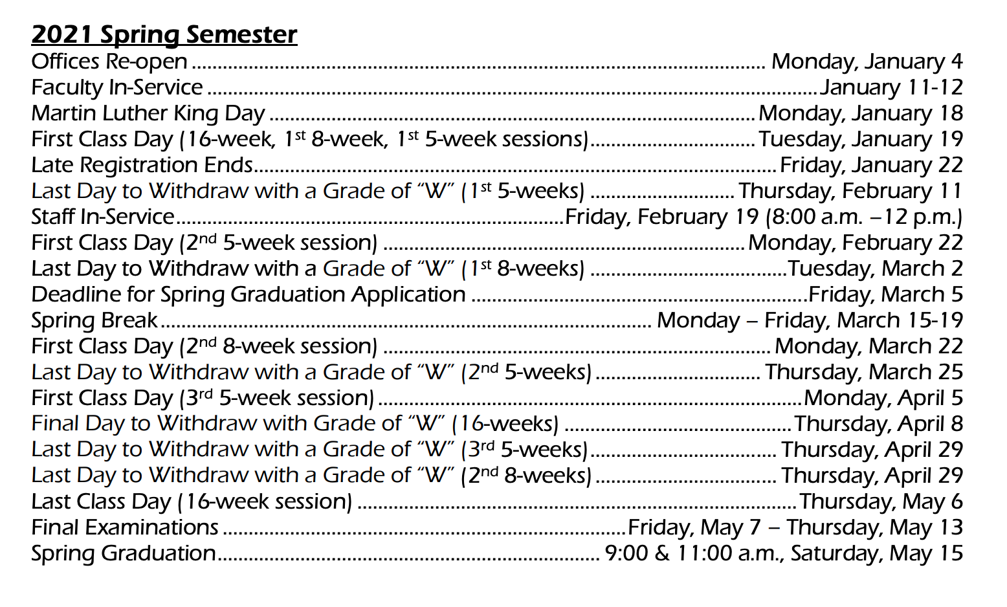
You did it!
