HIST 1301: U.S. History I
Course Syllabus for Spring 2021 example: Fall 2011

“Northeast Texas Community College exists to provide responsible, exemplary learning opportunities.”

Dr. Melissa Fulgham
Office: Humanities 128E
Phone: 903-434-8253
Email: mfulgham@ntcc.edu
Office Hours | Monday | Tuesday | Wednesday | Thursday | Friday | Online
 | 9:30-12:20  1:30-3:30 | 8:00-12:20 | 9:30-12:20  1:30-3:30 | 8:00-12:20 | By appointment
The information contained in this syllabus is subject to change without notice. Students are expected to be aware of any additional course policies presented by the instructor during the course.
Course Description:
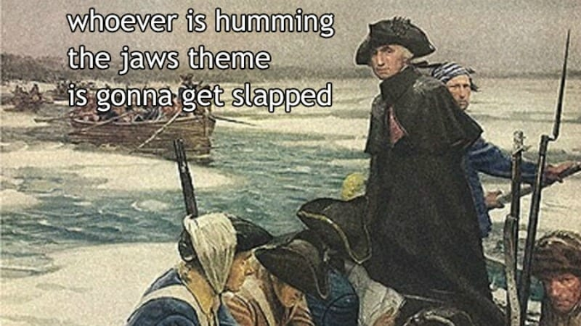
A survey of the social, political, economic, cultural, and intellectual history of the United States from the pre-Columbian era to the Civil War/Reconstruction period. United States History I includes the study of pre-Columbian, colonial, revolutionary, early national, slavery and sectionalism, and the Civil War/Reconstruction eras. Themes that may be addressed in United States History I include: American settlement and diversity, American culture, religion, civil and human rights, technological change, economic change, immigration and migration, and creation of the federal government.

Required Textbook(s):
Students must have access to the McGraw-Hill Connect website for the duration of the semester, which includes access to an online textbook (Experience History: Interpreting America’s Past, 8th edition, Davidson, et. al.) and various assignments for this course. Tuition for this course includes access to this website. Please see the course website for more information on how to access the website.

Student Learning Outcomes:

Upon successful completion of this course, students will:

Create an argument through the use of historical evidence. (history essay)

Analyze and interpret primary and secondary sources. (daily activities in-class and online)

Analyze the effects of historical, social, political, economic, cultural, and global forces on this period of United States history. (exam)

Evaluation/Grading Policy:
Grades in this course will be weighted. Course grades will be determined as follows:

25% MidTerm Exam
25% Final Exam
25% History Essay
25% Participation (5% Online, 20% In-Class Activities)

Participation

In-Class Activities

In-class activities vary from game-based learning activities, analysis of primary source documents, such as advertisements and television shows of an era, and class discussions. By their very nature they cannot be made up.

Online (SmartBook Exercises)
Students will be required to complete SmartBook Exercises for each assigned chapter. Students will read a chapter and answer questions on the reading. Grades are based on completion of the module by the designated due date and not by the number of correct/incorrect answers. If a learner completes only 70% of the module by the due date, then the student receives a 70%; if a learner completes 100% of the module by the due date, then the student receives a 100%.

Student Responsibilities/Expectations:
Late Assignment Policy
Assignments not submitted by the due date and time will be counted as late. This is non-negotiable unless two conditions are met: 1) a valid excuse is provided; 2) the student must contact the instructor with the valid excuse prior to the assignment’s due date and time.

NTCC Academic Honesty Statement:
"Students are expected to complete course work in an honest manner, using their intellects and resources designated as allowable by the course instructor. Students are responsible for addressing questions about allowable resources with the course instructor. NTCC upholds the highest standards of academic integrity. This course will follow the NTCC Academic Honesty policy stated in the Student Handbook."

Academic Ethics:
The college expects all students to engage in academic pursuits in a manner that is beyond reproach. Students are expected to maintain complete honesty and integrity in their academic pursuit. Academic dishonesty such as cheating, plagiarism, and collusion is unacceptable and may result in disciplinary action. Refer to the student handbook for more information on this subject.
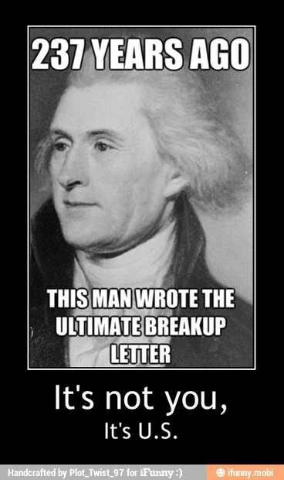

ADA Statement:
It is the policy of NTCC to provide reasonable accommodations for qualified individuals who are students with disabilities. This College will adhere to all applicable federal, state, and local laws, regulations, and guidelines with respect to providing reasonable accommodations as required to afford equal educational opportunity. It is the student’s responsibility to request accommodations. An appointment can be made with Katherine Belew, Academic Advisor/Coordinator of Special Populations located in the College Connection. She can be reached at 903-434-8218. For more information and to obtain a copy of the Request for Accommodations, please refer to the NTCC website - Special Populations.

Family Educational Rights and Privacy Act (Ferpa):
The Family Educational Rights and Privacy Act (FERPA) is a federal law that protects the privacy of student education records. The law applies to all schools that receive funds under an applicable program of the U.S. Department of Education. FERPA gives parents certain rights with respect to their children’s educational records. These rights transfer to the student when he or she attends a school beyond the high school level. Students to whom the rights have transferred are considered “eligible students.” In essence, a parent has no legal right to obtain information concerning the child’s college records without the written consent of the student. In compliance with FERPA, information classified as “directory information” may be released to the general public without the written consent of the student unless the student makes a request in writing. Directory information is defined as: the student’s name, permanent address and/or local address, telephone listing, dates of attendance, most recent previous education institution attended, other information including major, field of study, degrees, awards received, and participation in officially recognized activities/sports.

Alternative Instruction Mode
This class uses Blackboard for SmartBook online activities. This class will also be part of a pilot group using Microsoft Teams for communication. If circumstances warrant, class instruction will move online.

Tentative C lass Schedule
Date | In-Class Activities (Mon & Wed) | Online Activity
Week 1: 1/19-1/24 | Course Introduction  Why did Europe conquer the Americas, and not the other way around? Why wasn't it China or Africa? | Ch 1 due 11:59pm Sunday
Week 2:  1/25-1/31 | Why is the year 1492 significant?  Why were the English so late in colonizing the Americas? | Ch 2 due 11:59pm Sunday
Week 3: 2/1-2/7 | What was Bacon's Rebellion about and how did it lead to an increased reliance on slaves?  How did the northern English colonies differ from the southern colonies? | Ch 3 due 11:59pm Sunday
Week 4: 2/8 – 2/14 | What really happened at Salem and why?  How did the middle colonies differ from the southern or northern colonies? | Ch 4 due 11:59pm Sunday
Week 5: 2/15-2/21 | How did a religious revival (Great Awakening) help pave the way for the American Revolution?  Why did the colonists revolt? | Ch 5 due 11:59pm Sunday
Week 6:  2/22-2/28 | How did 13 raggedy colonies manage to beat one of the world's greatest superpowers? | Ch 6 due 11:59pm Sunday
Week 7:  3/1-3/7 | What form of government did the U.S. have during the Revolution,and why?  How does the Constitution differ from the Article of Confederation, and why? | Ch 7 due 11:59pm Sunday
Week 8: 3/8-3/14 | Jeopardy! Review for MidTerm  MidTerm Exam | Ch 8 due 11:59pm Sunday
 | *** Spring Break ****
Week 9: 3/22-3/28 | Why did political parties develop under the Constitution?  How did the rise of political parties impact American politics? | Ch 9 due 11:59pm Sunday
Week 10: 3/29-4/4 | Why did a market revolution take place?  How did the market revolution impact the lives of Americans? | Ch 10 due 11:59pm Sunday
Week 11: 4/5-4/11 | How did democracy "expand"?  Why did a second political party system develop? | Ch 11 due 11:59pm Sunday
Week 12: 4/12-4/18 | What was there a second religious revival (Second Great Awakening)?  How did religious and secular ideology lead to a rise in reform movements? | Ch 12 due 11:59pm Sunday
Week 13: 4/19-4/25 | What was it like to live in the antebellum South?  Why and how did the nation continue to expand? | Ch 13 due 11:59pm Sunday
Week 14: 4/26-5/2 | How did adding western states cause the slavery issue to become so divisive in the United States?  Why did South Carolina secede in December 1860? Why did 10 other states later follow? | Ch 14 due 11:59pm Sunday
Week 15: 5/3-5/9 | Why did the North win the Civil War? Why was it the most devastating war in American history? | Ch 15 due 11:59pm Sunday
Week 16:  5/10-5/13 | Final Exam will be Thursday May 13 @ 2:00-3:50 in same room | Ch 16 due 11:59pm THURSDAY

