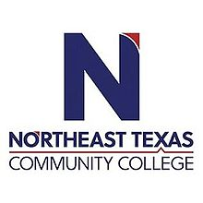
Carol Slider, MSN RN
Adjunct Professor of Nursing

Office: UHS # 205
Phone: 903-434-8277
Email: cslider@ntcc.edu

“Northeast Texas Community College exists to provide responsible, exemplary learning opportunities.

Education:

Institution | Major/Areas | Degree | Year(s)
Regis University | Nursing Science | Masters of Science in Nursing | Graduated 5/2010
The University of Texas Medical Arlington | Nursing Science | Bachelor of Science in Nursing | Graduated 5/1997
Paris Junior College | Nursing Science | Associate of Science in  Nursing | Graduated 5/1987
Central Texas College | Nursing | Licensed Vocational Nurse | Graduated 5/1979

Experience:

Institution | Year(s)
Northeast Texas Community College | 2020 to present
Titus Regional Medical Center- Chief Nursing Officer | 2005-2020

Courses Taught at NTCC (last 5 years):
RNSG 1128: Intro to Healthcare Concepts
RNSG 1430: Health Care Concepts I
RNSG 1125: Professional Nursing Competencies I
RNSG 1126: Professional Nursing Competencies II
RNSG 1533: Healthcare Concepts II
oncepts

Professional Memberships:

Sigma Theta Tau

Texas Community College Association

American Nurses Association
Texas Nurses Association District 35
Tx Community College Teachers Association

