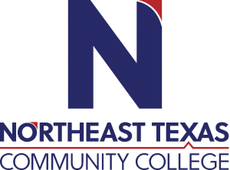 | Daisy Bates  Office: University Health Science 111  Phone: 903-434-8354  Email: dbates@ntcc.edu
 | “Northeast Texas Community College exists to provide personal, dynamic learning experiences empowering students to succeed.”

Education:

Institution | Major/Areas | Degree | Year(s)
Kaplan University | Higher Education with emphasis in Online Teaching | Master of Science | 2013-2014
Texas A&M Texarkana | Administrative/Organizational Leadership | Bachelor of Applied Arts and Science | 2007-2009

Teaching Experience:
Institution | Year(s)
Northeast Texas Community College | 3 years
Northeast Texas Community College Adult Education Ctr. | 2 years

Courses Taught at NTCC (last 3 years):
EDUC 1300 Learning Frameworks for Mathematics and Collegiate Learning

Significant Professional Publications/Presentations (last 3 years):

