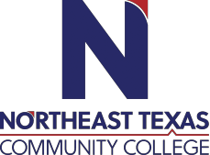
Fall Sophomore Honors Seminar (HIST 2322 and MUSI 1306)
Course Syllabus: Fall 2019
“Northeast Texas Community College exists to provide responsible, exemplary learning opportunities.”

Melissa Fulgham, Ph.D.
Office: Humanities Building Office 128E
Phone: 903.434.8253
Email: mfulgham@ntcc.edu (respond to emails within 24 hours)

Office Hours  (and by appointment) | Monday | Tuesday | Wednesday | Thursday | Friday | Online
 | 12:30-3:30 | 10:00-12:00  1:30-3:30 | 12:30-3:30 | 10:00-12:00  1:30-3:30

Andrew Daniel, D.M.A.
Office: Whatley 126
Phone: 903.434.8185
Email: adaniel@ntcc.edu

Office Hours | Monday | Tuesday | Wednesday | Thursday | Friday | Online
 | 12:30-4:00 |  | 11:00-1:30  3:00-4:00

The information contained in this syllabus is subject to change without notice. Students are expected to be aware of any additional course policies presented by the instructor during the course.
Catalog Course Description (include prerequisites): A survey of the social, political, economic, cultural, religious and intellectual history of the world from the 15th century to the present. The course examines major cultural regions of the world in Africa, the Americas, Asia, Europe, and Oceania and their global interactions over time. Themes include maritime exploration and transoceanic empires, nation/state formation and industrialization, imperialism, global conflicts and resolutions, and global economic integration. The course emphasizes the development, interaction and impact of global exchange.
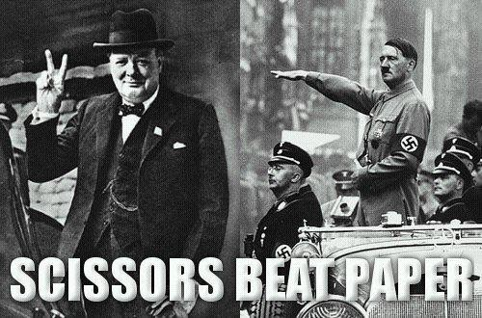
What’s unique in this particular seminar course: Focus will be on what’s happening in the world and how that impacted the arts. Or, is it the other way around? Highly interactive course designed to encourage creativity and thoughtful analysis of that symbiotic relationship.

Required Textbooks:

The Humanistic Tradition, Vol II, Fiero
ISBN:

The Elements of Style, Strunk and White ISBN: 0-205-30902-X

Student Learning Outcomes (HIST 2322):
Upon successful completion of this course, students will:
1. Create an argument through the use of historical evidence.
2. Analyze and interpret primary and secondary sources.
3. Analyze the effects of historical, social, political, economic, cultural, and global forces on this period of world history.

Student Learning Outcomes (MUSI 1306):
Upon successful completion of this course, students will:
1. Identify musical works and elements in a variety of styles.
2. Analyze the elements and structures of music using appropriate terminology.
3. Critically evaluate the influence of social, political, technological, and/or cultural ideas on music.
4. Articulate the significance of music as an art form within historical, cultural and social contexts.

Lectures & Discussions:
See tentative daily list.

Evaluation/Grading Policy:
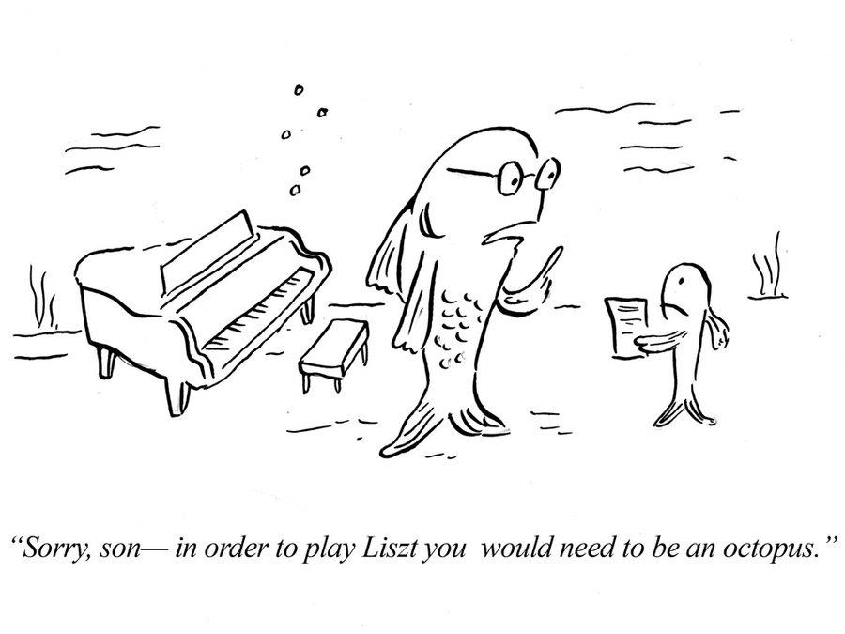
Students receive the same grade for both HIST 2322 and MUSI 1306. This honors seminar is treated as if it were a single six-hour class.

Daily Quizzes: | 10%
In-class activities: | 10%
Music Composition Assignments: | 10%
3 Exams: | 10%
Comprehensive Final Exam: | 10%
Live Performance Final: | 10%
Research Paper: | 40%
(paper grade is broken down into various parts such as topic selection, bibliography, peer review)

Daily Quizzes: Every class will begin with a quiz over the assigned materials. One quiz will cover material from the readings assigned. Quizzes may also be comprehensive and include material covered earlier in the course. The lowest two quiz grades will be dropped.
In-class Activities: Every class period will provide students the opportunity to participate via class discussion or hands- on activity. Activities will vary throughout the semester and include options such as Chinese calligraphy, making clay African masks, composing music for the piano, learning to play guitar, and drawing world maps. By the very nature of their task, they cannot be made up. A missed class means a missed activity.
Live Performance Final: One of the themes throughout the course is the relevance and meaning of artistic expression. The live performance final gives students a chance to demonstrate that themselves. Live performance finals will be videoed and posted online. You will come up with a creative presentation piece that is “musical” in some way, as loosely defined, and that has special meaning to you in some way. Past examples include composing and singing an original song that discusses a significant event in your life; a math major using dice as a random number generator to determine specific notes played in a song; a dancer combining unique styles from three different countries to showcase a truly multi-national outlook.
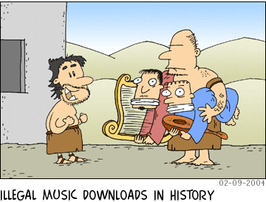
Original Research Paper: Students will write an 8-10 page paper on a topic of their choice, as approved by the instructors. It can pertain to almost any topic that interests you, since history includes everything that ever happened. It is anticipated that this paper will be exceptionally well-written, thoroughly researched and of publishable quality. At a minimum, it should include 3 primary sources and 6 secondary sources. Keep in mind that the more original research the better it will be regarded. The instructors will help you locate journals and venues to submit the paper to for possible publication. Ideally students should choose a topic that they are passionate about and could possibly relate directly to their chosen field of study and future career. As a result, students should therefore be willing to put in the long hours needed to produce a high-quality product.
Research Presentation: Each student will share their research with the class in a creative manner. Options include, but are not limited to, a beautifully designed power point presentation, YouTube video, prezi, powtoon, poster display, or another format. Dressing the part, bringing food or items to class, performing a musical piece, painting a collage are all permissible aspects. Do not limit yourself in creativity! Presentation grades will be based on creativity as well as content. Students will have an hour to share their findings in a creative, innovative, attention-getting manner.

NTCC Academic Honesty Statement: Students are expected to complete course work in an honest manner, using their intellects and resources designated as allowable by the course instructor. Students are responsible for addressing questions about allowable resources with the course instructor. NTCC upholds the highest standards of academic integrity. This course will follow the NTCC Academic Honesty policy stated in the Student Handbook.
ADA Statement: It is the policy of NTCC to provide reasonable accommodations for qualified individuals who are students with disabilities. This College will adhere to all applicable federal, state, and local laws, regulations, and guidelines with respect to providing reasonable accommodations as required to afford equal educational opportunity. It is the student’s responsibility to request accommodations. An appointment can be made with Katherine Belew, Academic Advisor/Coordinator of Special Populations located in the Student Services. She can be reached at 903-434-8218. For more information and to obtain a copy of the Request for Accommodations, please refer to the NTCC website - Special Populations.
Family Educational Rights and Privacy Act (FERPA): The Family Educational Rights and Privacy Act (FERPA) is a federal law that protects the privacy of student education records. The law applies to all schools that receive funds under an applicable program of the U.S. Department of Education. FERPA gives parents certain rights with respect to their children’s educational records. These rights transfer to the student when he or she attends a school beyond the high school level. Students to whom the rights have transferred are considered “eligible students.” In essence, a parent has no legal right to obtain information concerning the child’s college records without the written consent of the student. In compliance with FERPA, information classified as “directory information” may be released to the general public without the written consent of the student unless the student makes a request in writing. Directory information is defined as: the student’s name, permanent address and/or local address, telephone listing, dates of attendance, most recent previous education institution attended, other information including major, field of study, degrees, awards received, and participation in officially recognized activities/sports.
Other Course Policies: Turn off cell phones and other devices that unnecessarily cause distractions. Texting in class is not acceptable. If you have an emergency call, then step outside the classroom to answer it so as not to be a distraction. If texting becomes a problem, the offending student will be asked to leave. If the problem continues, offending students will be withdrawn.

Tentative Daily Schedule

Date | Topic | Homework due before coming to class
Mon, Aug 26 | Course Introduction: Getting to know each other activities, reaction pieces  Setting up some course themes, symbiotic relationship between ideas and behavior
Wed, Aug 28 | History is more than what happened – it involves understanding why the past happened the way that it did. “From Fonics to Facebook”  Chinese Calligraphy: hands-on history | Watch video online (or read transcript available)
Mon, Sept 2 | No Class: Labor Day Holiday
Wed, Sept 4 | Religion from the ancient world to the Protestant Reformation in the west
Mon, Sept 9 | PAPER TOPICS selected
 | Book 4: Faith, Reason, and Power in the Early Modern World
Wed, Sept 11 | Catholic Reformation and the Baroque Style / Absolute Power and the Aristocratic Style | Ch 20, 21
Mon, Sept 16 | Rembrandt’s Nightwatching  Baroque Style in the Protestant North | Ch 22
Wed, Sept 18 | Scientific Learning and the New Learning, The Enlightenment: The Promise of Reason | Ch 23, 24
Mon, Sept 23 | The Limits of Reason (Transatlantic Slave Trade) | Ch 25
Wed, Sept 25 | Eighteenth Century Art, Music, and Society | Ch 26
Mon, Sept 30 | BIBLIOGRAPHIC listing of sources - EXAM OVER BOOK 4
 | Book 5: Romanticism, Realism, and the Nineteenth-Century World
Wed, Oct 2 | The Romantic View of Nature / The Romantic Hero | Ch 27, 28
Mon, Oct 7 | The Romantic Style in Art and Music | Ch 29
Wed, Oct 9 | Industry, Empire, and the Realist Style | Ch 30
Mon, Oct 14 | Thesis Statement (argument) due , Topic Sentences (tentative structure of argument and paper) due
Wed, Oct 16 | The Move Toward Modernism | Ch 31
Mon, Oct 21 | Online Peer Reviews – EXAM OVER BOOK 5
 | Book 6: Modernism, Postmodernism, and the Global Perspective
Wed, Oct 23 | Modernist Assault, The Freudian Revolution | Ch 32, 33
Mon, Oct 28 | Metropolis
Wed, Oct 30 | African Masks in clay lab
Mon, Nov 4 | Total War, Totalitarianism, and the Arts | Ch 34
Wed, Nov 6 | The Quest for Meaning | Ch 35
Mon, Nov 11 | Identity and Liberation | Ch 36
Wed, Nov 13 | The Information Age | Ch 37
Mon, Nov 18 | Globalism: The Contemporary World | Ch 38
Wed, Nov 20 | EXAM OVER BOOK 6
Mon, Nov 25 | Thanksgiving Week
Wed, Nov 27 | Thanksgiving Week
Mon, Dec 2 | Presentations
Wed, Dec 4 | Presentations
Mon, Dec 9 | Presentations (Take-Home Comprehensive Final Exam)
Wed, Dec 11 | Live Performance Presentation Final

Winspear Opera House options:

W.A. MOZART

The Magic Flute
October 18, 20, 23, 26, November 1, 3, 2019

NIKOLAI RIMSKY-KORSAKOV

The Golden Cockerel
October 25, 27, 30, November 2, 2019

