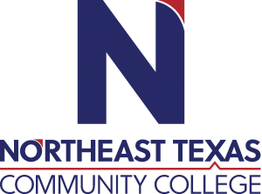 | Emily Mikel  Instructor of Certified Nurse Aide  Office: UHS 205  Phone: 903-767-7451  Email: emikel@ntcc.edu
 | “Northeast Texas Community College exists to provide personal, dynamic learning experiences empowering students to succeed.”

Education:

Institution | Major/Areas | Degree | Year(s)
University of Texas at Tyler | Bachelors of Nursing | BSN | 2022
Northeast Texas Community College | Professional Nursing | ADN | 2020
Northeast Texas Community College | Vocational Nursing | Certificate of Competency | 2018

Teaching Experience:
Institution | Year(s)
Northeast Texas Community College | 2020- present

Courses Taught at NTCC (last 3 years):
NURA 1401- Nurse Aide for Healthcare
NURA 1407 – Body Systems

Significant Professional Publications/Presentations (last 3 years):
N/A

