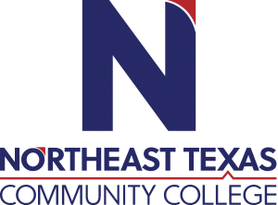 | Kenneth Adcock  Office: Ore City High School Room 318  Phone: (903)-309-0749  Email:kadcock@ntcc.edu/adcockk@ocisd.net
 | “Northeast Texas Community College exists to provide personal, dynamic learning experiences empowering students to succeed.”

Education:

Institution | Major/Areas | Degree | Year(s)
East Texas Baptist Univ | Speech Communication | B.S.E | 2010-2015
East Texas Baptist Univ | Educational Leadership | Master of Education | 2015-2016
Regent University | Communication Studies | Doctor of Philosophy | 2019-Present

Teaching Experience:
Institution | Year(s)
Marshall ISD | 2015-2019
Ore City ISD | 2019-Present
Tyler Junior College | 2021-Present
North East Texas Community College | 2021-Present

Courses Taught at NTCC (last 3 years):
List courses taught at NTCC here. For example:
NONE TO DATE

Significant Professional Publications/Presentations (last 3 years):
Type significant professional publications/presentations here (include title, publication, and date.)
NONE TO DATE

