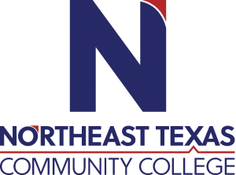 | Page Petrucka, PhD  Office: Whatley Center, 142  Phone: x 8395  Email: ppetrucka@ntcc.edu
 | “Northeast Texas Community College exists to provide personal, dynamic learning experiences empowering students to succeed.”

Education:

Institution | Major/Areas | Degree | Year(s)
Texas Tech University | Fine Arts/Theatre | PhD | 2014
Utah State University | Theatre Arts | Master’s | 2003
Southern Utah University | Theatre Arts | Bachelor’s | 1993

Teaching Experience:
Institution | Year(s)
Northeast Texas Community College | 2021-present
Independence Community College | 2018-2021
Utah Valley University | 2015-2018
Brigham Young University | 2016-2018

Courses Taught at NTCC (last 3 years):
Theatre Appreciation
History of the Theatre I
Theatre Practicum
Acting I
Script Analysis

Significant Professional Publications/Presentations (last 3 years):
Winner in the Texas Educational Theatre Association’s Playfest (2021) - 10-minute play
Alternate in the William Inge Theatre Festival Playlab (2020)– 10-minute play
A 1940s Christmas Carol – Published in 2020 by Next Stage Press, Kennedy Center American College Theatre Festival Region V Special Recognition, 2021

