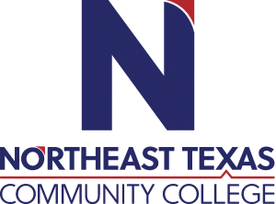 | Shana Anderson  Office: BS 109  Phone: (903) 434-8292  Email: sanderson@ntcc.edu
 | “Northeast Texas Community College exists to provide personal, dynamic learning experiences empowering students to succeed.”

Education:

Institution | Major/Areas | Degree | Year(s)
Texas A&M--Commerce | Mathematics | B.S. | 4

Teaching Experience:
Institution | Year(s)
Bethel Christian Academy  Christian Home Educators Coop (volunteer) | 1999-2003, 2007-2008
 | 2009-present

Courses Taught at NTCC (last 3 years):
First year to teach Developmental Math 0200 and 0404.

Significant Professional Publications/Presentations (last 3 years):

