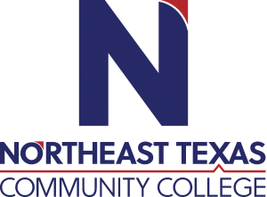 | Dacey Ellington  Office: Harts Bluff ISD  Phone: 903-577-1146  Email: dellington@ntcc.edu
 | “Northeast Texas Community College exists to provide personal, dynamic learning experiences empowering students to succeed.”

Education:

Institution | Major/Areas | Degree | Year(s)
Sam Houston State University | History  Secondary Education | Bachelor of Arts in History | 2003-2008
Texas A&M Commerce | History | Master of Science | Will finish December 2021

Teaching Experience:
Institution | Year(s)
Conroe ISD | 2008-2014
Harts Bluff ISD | 2016-present

Courses Taught at NTCC (last 3 years):
Dual Credit Course: U.S. History

