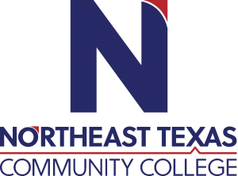 | Erin Robles  Office: BT 102  Phone: 903-434-8208  Email: erobles@ntcc.edu
 | “Northeast Texas Community College exists to provide personal, dynamic learning experiences empowering students to succeed.”

Education:

Institution | Major/Areas | Degree | Year(s)
Kilgore College | Manicurist | Certificate | 2012-2013
Northeast Texas Community College | Cosmetology Operator | Certificate | 2020-2021
Northeast Texas Community College | Cosmetology Instructor | Certificate | 2021-2021
Northeast Texas Community College | Cosmetology | Associates of Applied Science | 2020-2022

Teaching Experience:
Institution | Year(s)
Northeast Texas Community College (Assistant to Cosmetology Instructor) | 2021-2022

Courses Taught at NTCC (last 3 years):
Assistant to Cosmetology Instructor

Significant Professional Publications/Presentations (last 3 years):

