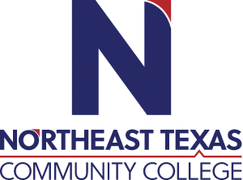 | Ms. Jennifer Perez  Office: TEAMS by appointment  Phone: 903.244.1782  Email: jperez@ntcc.edu
 | “Northeast Texas Community College exists to provide personal, dynamic learning experiences empowering students to succeed.”

Education:

Institution | Major/Areas | Degree | Year(s)
Texas A&M University – Texarkana | Organizational Leadership | Bachelor of Applied Arts & Sciences (BAAS) | 2014
Texas A&M University – Texarkana | Adult & Higher Education | Master of Science (MS) | 2021
Texas A&M University – Texarkana | Instructional Technology | Master of Science (MS) | In progress

Teaching Experience:
Institution | Year(s)
Northeast Texas Community College (NTCC) | 2022

Courses Taught at NTCC (last 3 years):
EDUC 1300 Learning Frameworks

