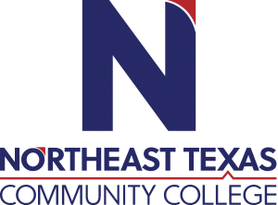 | Jon McCullough  Office: Admin 105  Phone: 903-434-8115  Email: jmccullough@ntcc.edu
 | “Northeast Texas Community College exists to provide personal, dynamic learning experiences empowering students to succeed.”

Education:

Institution | Major/Areas | Degree | Year(s)
Oklahoma State University | Secondary Education | B.S. | 81-85
University Of Oklahoma | Educational Psychology | M.Ed. | 90-92
Texas A&M-Commerce | Secondary and Higher Education | Ed.D. | 96-99

Teaching Experience:
Institution | Year(s)
Northeast Texas Community College | 2014-2022

Courses Taught at NTCC (last 3 years):
Psyc 2389
Psyc 2389
Psyc 2389

Significant Professional Publications/Presentations (last 3 years):

