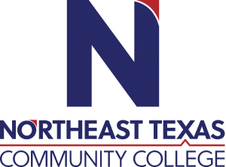 | Anna Ingram  Office: Student Services 126  Phone: 903-434-8366  Email: aingram@ntcc.edu
 | “Northeast Texas Community College exists to provide personal, dynamic learning experiences empowering students to succeed.”

Education:

Institution | Major/Areas | Degree | Year(s)
Texas A&M University - Texarkana | Educational Leadership | Doctorate (54/60 SCR completed) | Current
Texas A&M University - Texarkana | Interdisciplinary Studies – English, Psychology, Education | Master of Science | 1998
Texas A&M University – Corpus Christi | Secondary Education/English | Bachelor’s Science | 1990

Teaching Experience:
Institution | Year(s)
Northeast Texas Community College | 1998-Present

Courses Taught at NTCC (last 3 years):
ENGL1301 – English Composition I
ENGL1302 – English Composition II
ENGL2322 – British Literature I
ENGL2323 – British Literature II

Significant Professional Publications/Presentations (last 3 years):

